**ME 222**

**NATURE AND PROPERTIES OF MATERIALS**



**Lab Report**

**Experiment No. : 6**

**MEASUREMENT OF HARDNESS**

Instructor: Dr. Kamal K. Kar

Department of Mechanical Engineering

**Date of Experiment:** 8 March 2016 **Date of submission:** 17 March 2016

**Group – A2**

**14042 - Affan Ahmad**

**14048 – Akash Singh**

**14052 – Akhil Amod**

**14059 – Akshay Bagde**

**14060 – Akshay Bhola**

**14062 – Akshay Sharma**

**14065 – Albart Jose**

**AIM OF THE EXPERIMENT:-**

1. To measure the hardness of soft materials (rubber) using Shore-A and Shore-D testing.
2. To measure the hardness of metals (Aluminium) using Brinell Hardness testing

Importance of the experiment:-

This experiment provides information about hardness of various materials . This information may correlate to tensile strength, wear resistance, ductility, or other physical characteristics of metallic materials, and may be useful in quality control and selection of material.

**INTRODUCTION:-**

* **STRESS:** It is defined as the resistance of material to flow on application of external forces.
* **STRAIN:** It is the maximum amount of energy stored in the material until fracture point.
* **HARDNESS:** It can be defined as the resistance of metal to plastic deformation, usually be indentation, scratch or rebound. It is the property of the metal which provides it the ability to resist being permanently deformed on application of some load. Hardness is proportional to its resistance.
* **HARDNESS MEASUREMENT TESTS:**

1. Shore testing
2. Brinell Hardness Test
3. Rockwell Hardness Test
4. Vickers test

* **RESILIENCE:** It is the maximum amount of energy stored in the material until elastic point.

**EQUIPMENTS USED:-**

* Shore-A Durometer
* Shore-D Durometer
* Brinell hardness tester

**MATERIALS USED:-**

* 2 different rubber samples for Shore-A and Shore-D tests.
* Piece of Aluminium for Brinell Test

**EXPERIMANTAL CONDITIONS:-** Temperature: 25oC

**THEORY:-**

1. **BRINELL HARDNESS TEST:** It is determined by forcing a hard steel or carbide sphere of a specified diameter under a specified load into the surface of the material and measuring the diameter of the indentation left after the test. It is used to measure the hardness of metals having light and medium hardness. Using a desktop machine we press a hard steel ball of 10mm diameter into the surface of the metal under testing for duration of about 10-15s. First minor load is applied and then major load is applied. After the application of the loads the diameter of the indentation on the metal surface is measured optically using a microscope and thus the hardness is measured.

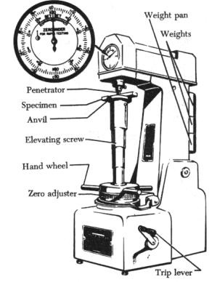

Fig-1: Brinell hardness Test Apparatus



Fig-2: Brinell hardness Test

The formula used to measure the hardness of the metal is:

**BHN = 2*F / pi*D*[D – sqrt( D^2 – d^2)]**

BHN: Brinell hardness number

F: Force applied

D: Diameter of the steel ball (mm)

d: Diameter of the indentation (mm)

* **Standards of measurement:** Brinell test methods is defined in **ASTM E10** and **ISO 6506** standards
* The following is the Brinell representation

**“70 HB 10/ 300/ 10”**

This represents that the hardness is ‘70’ using Brinell hardness test with ‘10mm’ diameter of the indenter, ‘300kgf’ of the major load and ‘10s’ duration of application of load.

1. **SHORE DUROMETER TESTING:** It is used to measure the hardness of elastomers and softer plastics such as polyolefin, fluoropolymers and vinyl. Shore hardness is a measure of the resistance of material to indentation by 3 spring-loaded indenter.

The hard pointed tip of the durometer is pressed against the material and the hardness is directly shown by the Durometer.

Durometer instrument is used to measure the hardness and thus is called ‘Durometer hardness’

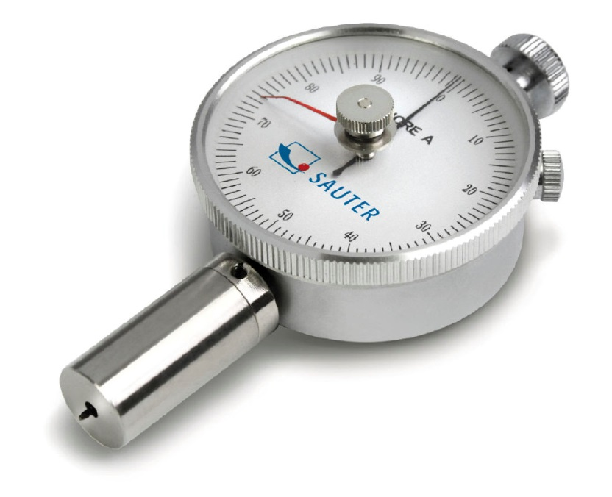

Fig-3: Durometer Instrument

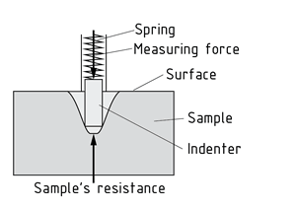

Fig-4: Mechanism of Shore-A and Shore-D methods

The most common scales are ASTMD2240 type A and type D scales. Linear relationship between the ASTMD2240 and elastic modulus given as follows-

**

*Where E = Young’s Modulus (MPa)*

*SA = ASTM D2240 type A Hardness*

*SD = ASTM D2240 type D Hardness*



Fig-5 : Schematic of Durometer Hardness test

1. **ROCKWELL HARDNESS TEST:** The Rockwell Hardness test is a hardness measurement based on the net increase in depth of impression as a load is applied. The indenter used may either be a steel ball or a spherical diamond tipped cone of 120 degree cone angle. This method is used to measure the hardness f metals and plastics.

Various scales in Rockwell testing:

* A Cemented carbides, thin steel and shallow case hardened steel
* B Copper alloys, soft steels, aluminium alloys, malleable iron, etc.
* C Steel, hard cast irons, pearlite malleable iron, titanium, deep case hardened steel and other materials
* harder than B 100
* D Thin steel and medium case hardened steel and pearlite malleable iron
* E Cast iron, aluminium and magnesium alloys, bearing metals
* F Annealed copper alloys, thin soft sheet metals
* G Phosphor bronze, beryllium copper, malleable irons
* H Aluminium, zinc, lead
* K, L, M, P, R, S, V Bearing metals and other very soft or thin materials, including plastics

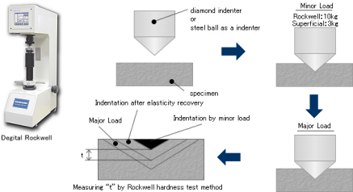

Fig – 6 Schematics of Rockwell testing

**Formula to find the hardness: HR = (depth of indentation due to major load(E)) – (depth of indentation due to minor loss(e) )**

**HR=t**

1. **VICKERS TEST:** this method is used to measure the hardness if very hard metals. The surface is subjected to standard pressure for a standard time gap using a pyramid shaped diamond. The diagonal of the indentation is measured and the hardness value checked from the chart.

**PROCEDURE:-**

* SHORE-A and SHORE-D
* Take the sample of material of which hardness is to be measured.
* Press the durometer against it and see the hardness shown digitally.
* Record the observation in observation table.
* BRINELL HARDNESS TEST
* Place the sample material on the workbench of Brinell machine.
* Rotate the anvil so that the indenter presses itself into the surface of the sample until the smaller dial pointer points between 2 and 3.
* Add the major load. Pull the lever to put load on the sample for certain time period.
* Rotate the anvil in the other direction and remove the load from the sample.
* Measure the diameter of the indentation in the sample using a microscope.
* Calculate the hardness and record observations.
* Do the following experiment by keeping time period constant and varying load 3 times
* Repeat it keeping load constant and time period varying.

**OBSERVATIONS AND GRAPHS:-**

* **SHORE-A and SHORE-D**

TABLE – 1

|  |  |
| --- | --- |
| HARD RUBBER  SHORE - D | SOFT RUBBER  SHORE - A |
| 102 shore D | 29 shore A |
| 106 shore D | 32 shore A |
| 109 shore D | 31 shore A |
| 108 shore D | 32 shore A |
| Mean : 106.25 shore D | Mean : 31 shore A |

* **BRINELL HARDNESS TEST -**  Keeping Dwell time constant

TABLE – 2

|  |  |  |  |  |
| --- | --- | --- | --- | --- |
| **Dwell time**  **(sec)** | **Load** | **Diameter, d (mm)** | **Brinell hardness No. (BHN)** | **Mean** |
| 10 | 250 kgf | 5.9 | 81 HB 10/250/10 | 114.6 BHN |
| 500 kgf | 6.6 | 125 HB 10/500/10 |
| 750 kgf | 7.0 | 164 HB 10/750/10 |

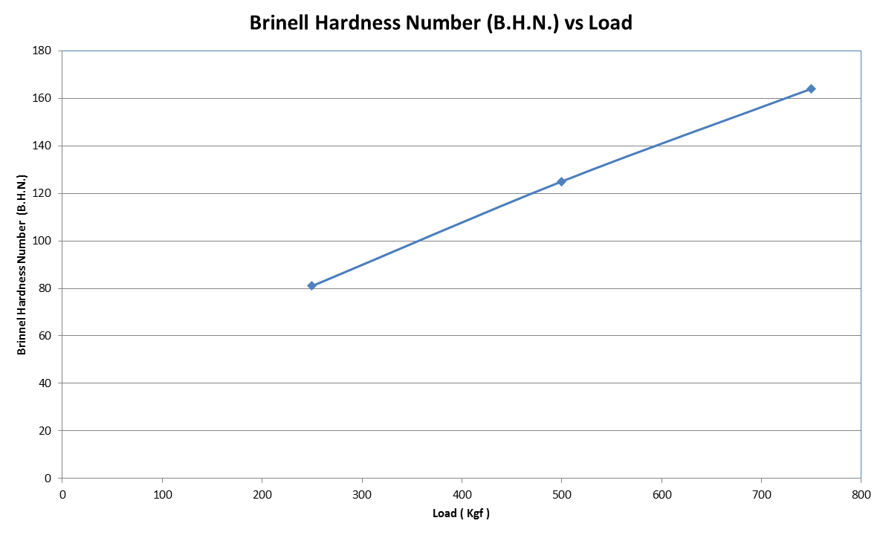

* **BRINELL HARDNESS TEST –** Keeping applied load constant

TABLE – 3

|  |  |  |  |  |
| --- | --- | --- | --- | --- |
| **Dwell time**  **(sec)** | **Load** | **Diameter, D1 (mm)** | **Brinell hardness No. (BHN)** | **Mean** |
| 5 | 250kgf | 5.9 | 81 BH10/250/5 | 78 BHN |
| 10 | 6.0 | 78 BH10/250/10 |
| 15 | 6.1 | 75 BH10/250/15 |

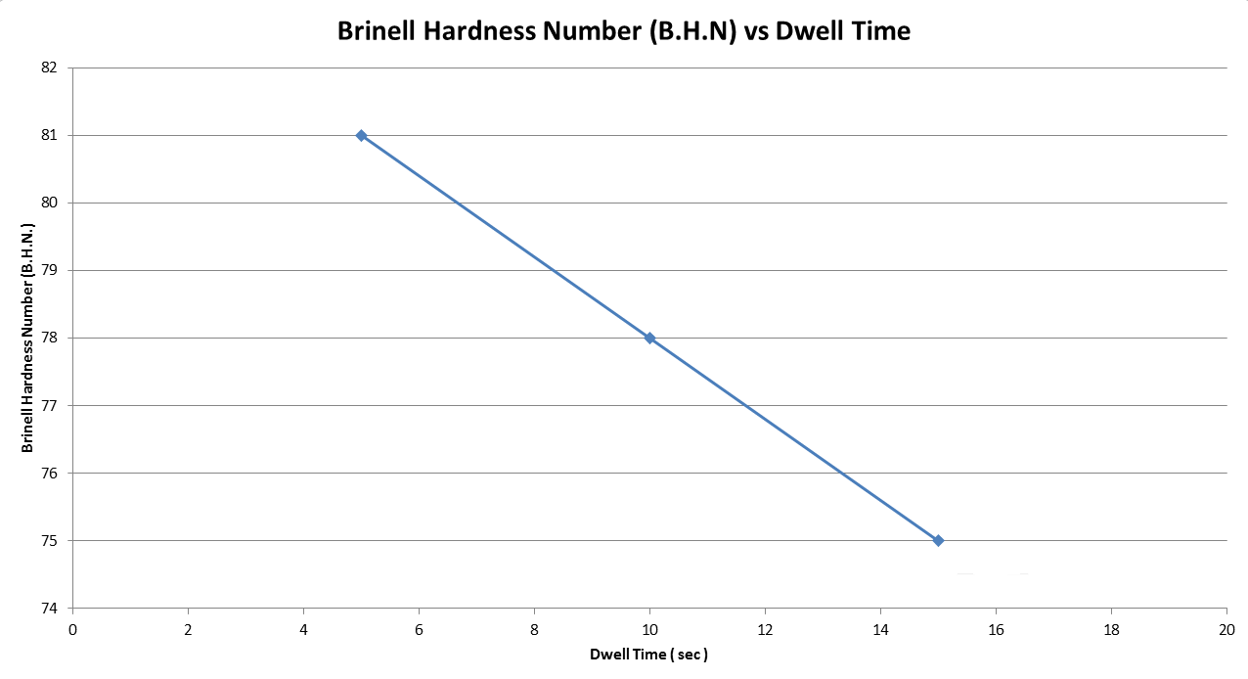

**Result:-**

1. Optimum time = 15 s.
2. Hardness of soft rubber = 31 shore A
3. Toughness of hard rubber = 106.25 shore D
4. Brinell hardness number under a load of 250 kgf for sample is 78 BH 10/250/10

**Conclusion:-**

1. Brinell’s hardness no. becomes stagnant after certain optimum time for a particular load.
2. Brinell’s hardness no. increases with increase in major load applied.

**PRECAUTIONS:-**

1. Handle the instruments and machinery carefully
2. Handle the weights carefully
3. Mandle the microscope carefully
4. Specimen should be 6mm thick
5. Dwell time should be measured carefull

**REFERENCES:-**

* Fundamentals of material science and engineering by William D. Callister, jr. 4th edition.
* Wikipedia.org

**THANK YOU**